Digi Skills 3.0
Data Analytics and Business Inteligence
Taseen Shafquat
Hands on Exercise 01

Step 1
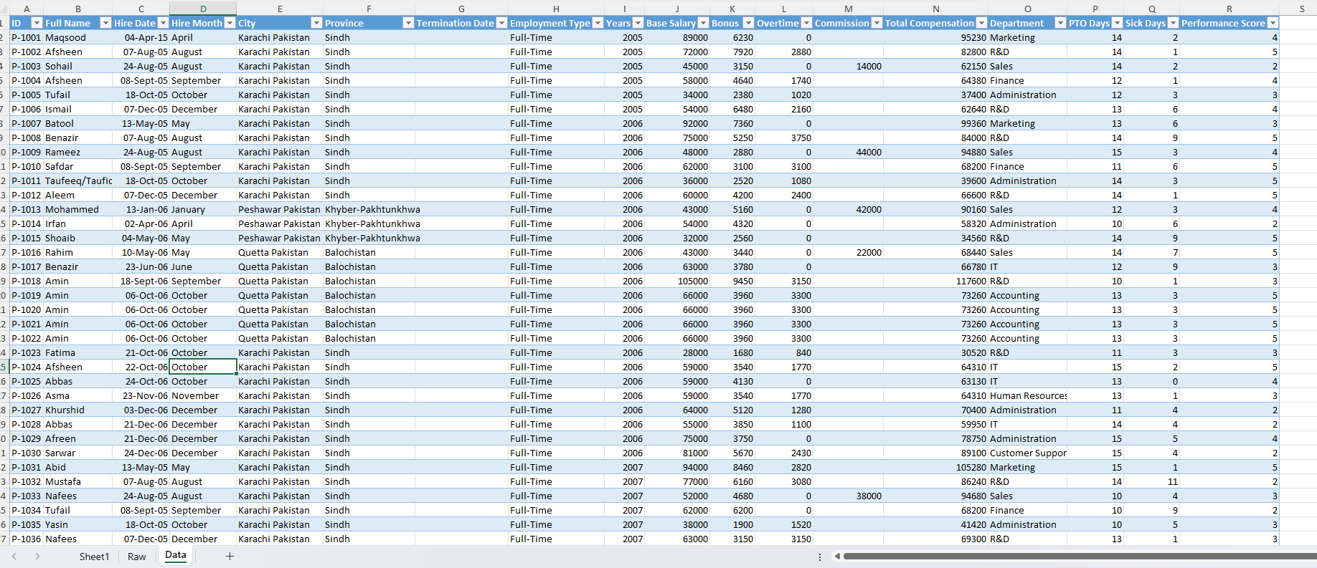

Step 2
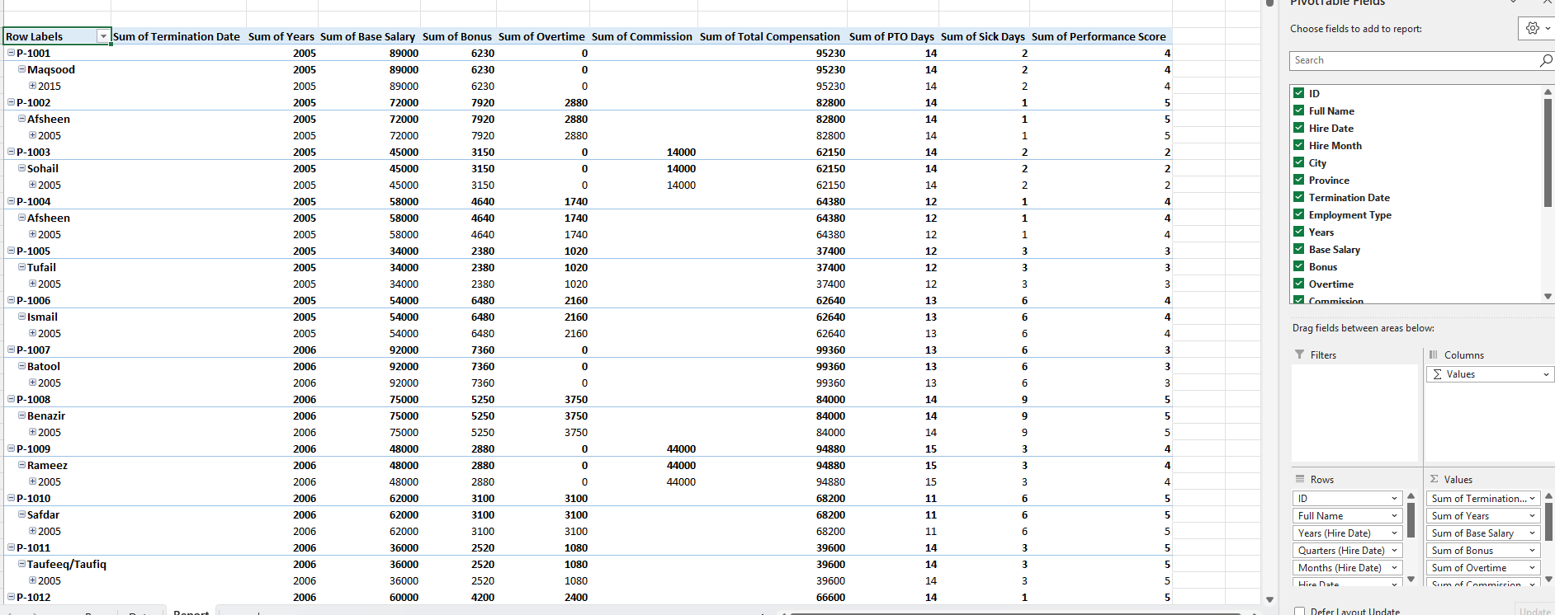

Step 3
Senario 1
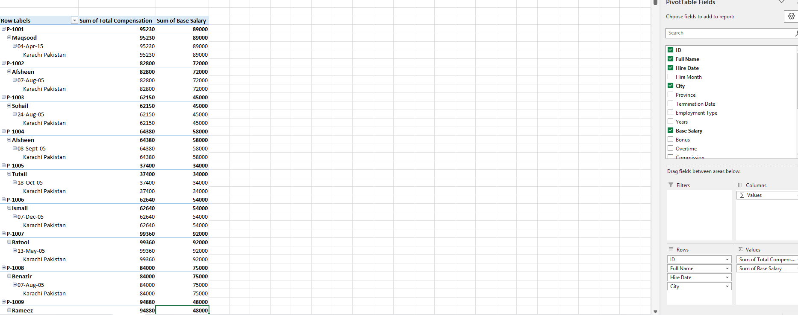

Senario 2

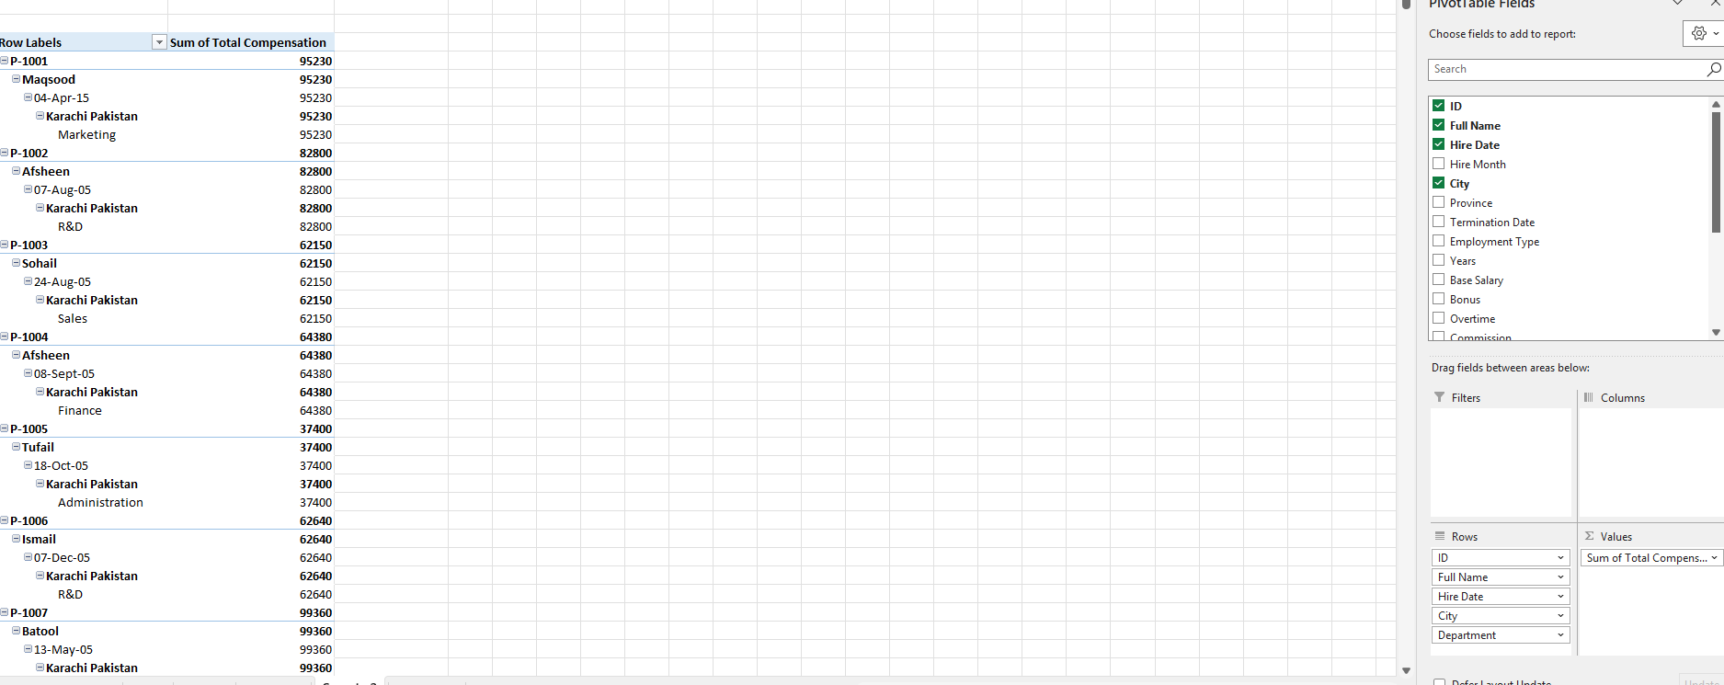

Senario 3
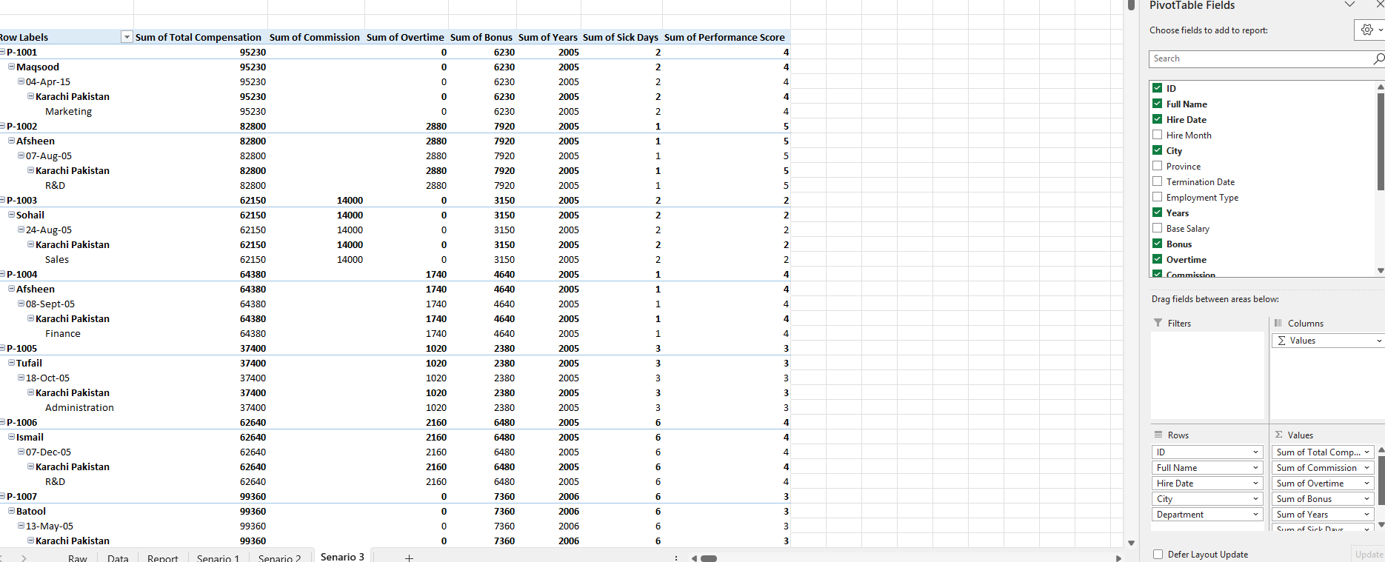

Step 4
Sort (largest to Small)- SN1
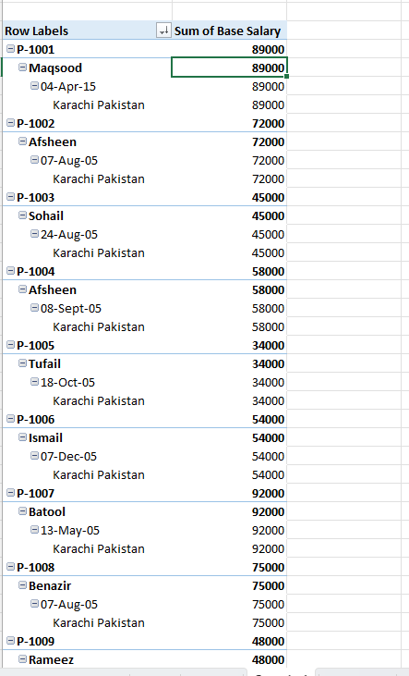

Step 4
Sort (largest to Small)- SN2
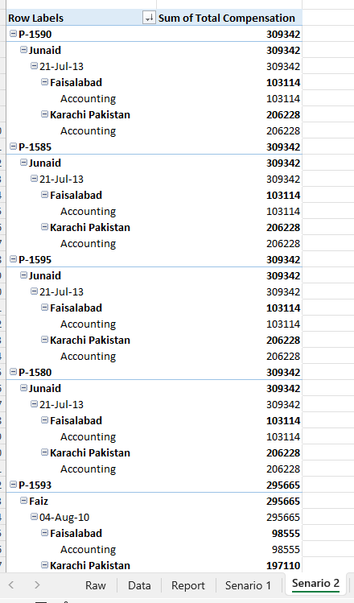

Sort (largest to Small)- SN3
